7th Grade Science Final Review CW



**Introduction to Scientific Design and Measurement**

1. An observation is…
   1. Research
   2. A fact based on the use of your five senses



* 1. The part of an experiment that you test
  2. A prediction based on an inference



1. “If I study more then I will get a higher grade” is an example of …
   1. Hypothesis



* 1. Observation
  2. Inference
  3. Controls

1. What are variables? ______________________________________________
2. Matching: What are these tools used to measure?
   1. Mass Thermometer ____



* 1. Time Triple Beam Balance ______
  2. Volume Stopwatch _____



* 1. Temperature Metric ruler _____



* 1. Distance Graduated Cylinder _____

1. What do these abbreviations mean:
   1. Kilo - 1000
   2. Centi – 100th
   3. Milli – 1000th

**Reading Graphs**

1. According to the pie chart which 2 methods of transportation add up to about 50% of how we get to school? Bus and walk

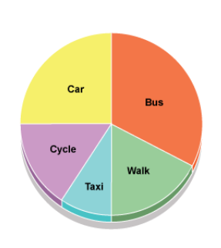

1. According to the graph below how many **more** grams of KNO3 can dissolve in water as the temperature rises from 60 to 80 degrees?

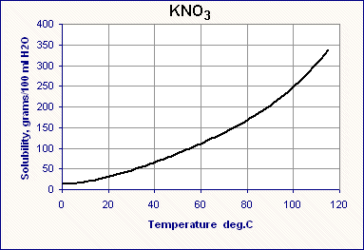

50 grams

1. According to the graph what percent of the moon is visible on day 40?

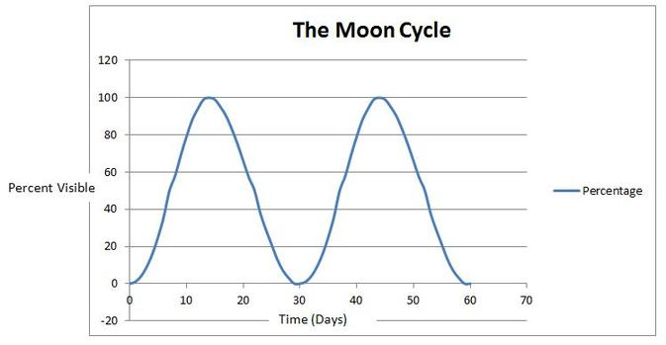

100%

**Properties of Matter**

1. Define the following terms:
   1. Matter – A physical substance
   2. Compounds – Composed of two or more elements; a mixture
   3. Elements – Cannot be broken down into simpler substances
   4. Mixtures - A substance made by mixing other substances together
2. Give an example of these physical properties of matter:

|  |  |
| --- | --- |
| Solubility | Salt and water |
| Conductivity | Metal |
| Magnetic | Magnet |
| Hardness | Wood |

1. Explain the following phase changes:
   1. Melting – The state changes from solid to liquid
   2. Freezing – The state goes from a liquid to solid
   3. Sublimation – It goes from solid to gas
   4. Evaporation – Goes from liquid to gas
   5. Condensation – Goes from gas to liquid
2. Are the following Elements, Compounds or Mixtures?
   1. Gold - Elements
   2. Water - Compound
   3. Chocolate milk - Mixture
3. The ability to dissolve is Solubility
4. A solution is a solution is a special type of homogeneous mixture composed of two or more substances.
5. The substance that is doing the dissolving is the solvent

The substance getting dissolved is the solute

1. Explain or draw the processes used to separate sand from salt and water in the diagram below:

Step 1: Filtration

The action or process of filtering something, in this case, filtering the sand from the water.

Step 2: Distillation

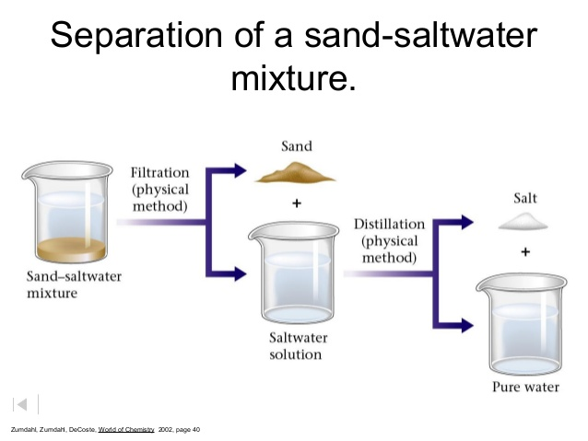



1. Which material in the diagram above dissolves in water? Salt
2. Which material in the diagram above is insoluble? Sand
3. Draw circles to represent the molecules in following terms:
   1. Solid:



* 1. Liquid:



* 1. Gas:



**Atoms and Chemistry**

1. Match the symbols to the parts of an atom:
   1. + Neutrons N
   2. N Protons +
   3. - Electrons -
2. The “Core of the atom” is the nucleus
3. What is the atomic number? The number of protons found in an atom
4. Use the periodic table below to find the atomic numbers for the following elements:
   1. He Helium
   2. S Sulfur
   3. K Potassium
   4. N Nitrogen
5. Protons + Neutrons = atomic mass
6. What is the periodic table? A tabular arrangement of the chemical elements,
7. If you have 8 protons and 8 electrons what is the atomic #? 8
   1. What element is it? Oxygen

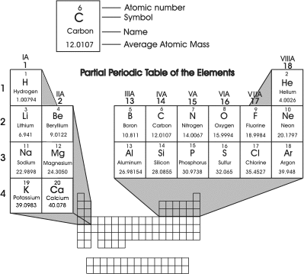

**Cells**

1. All living things need energy. Explain the two life processes below related to using energy:

|  |  |
| --- | --- |
| **Life processes** | **Explanation** |
| Photosynthesis | A process used by plants and other organisms to convert light energy into chemical energy |
| Cellular Respiration | A set of metabolic reactions and processes that take place in the cells of organisms to convert biochemical energy from nutrients into ATP |

1. The sum of all the energy used by a living thing:

A) Cellular Respiration

B) Homeostasis

C) Digestion

D) Metabolism



1. Put the following “levels of organization” terms in order from most simple to most complex: *cells, organism, tissue, organ system, organ*

a. Cells

b. Tissues

c. Organ

d. Organ system

e. Organism

1. What are the functions of the following organelles?
   1. Mitochondria – Produces energy
   2. Vacuole – Storage for the cell
   3. Cell membrane - A layer with proteins that protects the cell from its surroundings.
   4. Nucleus - Stores DNA and coordinates the cell's activities.
   5. Chloroplast - Contains most of the reaction during photosynthesis
   6. Cell wall – Protects the cell
2. The movement of “material” from a high concentration to a low concentration is called diffusion
3. The movement of WATER from a high concentration to a low concentration is called osmosis
4. Define mitosis:

Cell division that results in two daughter cells

1. How many cells will be present after 3 complete stages of mitosis (assuming you start with one cell)?

8 cells

1. Label each creature as unicellular or multicellular:
2. 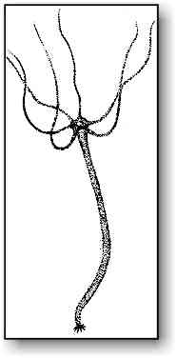 Multicellular b. 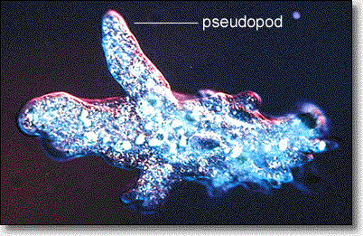 Unicellular c. 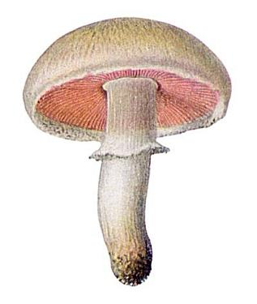Multicellular
3. is the result of uncontrolled Mitosis?

A) Photosynthesis

B) Formation of twins

C) Cancer



D) None of the above

**Human Body Systems**

* + - List the major **organs** in each system
    - Explain the **functions** of each system.

1. Skeletal/Muscular

Skull, muscle tissue, blood vessels. Provides support and movement

1. Circulatory

Lungs, makes you breathe

1. Nervous

Brain, coordinates its actions by transmitting signals to and from different parts of its body.

1. Endocrine

Pancreas, secrete hormones

1. Respiratory

Nose, gas exchange

1. Digestive

Stomach, breaks down food

1. Immune

Liver, fights off viruses and bacteria

1. Excretory

Kidney, gets rid of wastes

How do the systems below work together?

Example: respiratory and circulatory

Transports oxygen to the working muscles.

Example: skeletal and muscular

The muscular system is responsible for movement of the body and the skeletal is responsible for the support of the body.

Example: muscular and nervous

Receptors in muscles provide the brain with info about body position and movement

**Rocks and Minerals**

1. Research and define these terms:
   1. Atmosphere: The layers of gases
   2. Hydrosphere: The water on Earth’s surface
   3. Lithosphere: The outer most shell of a planet.
2. The diagram below shows fossils and the rock layers in which they are found.

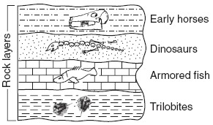

Which fossil is the oldest in the cross-section diagram?

1. Armored fish
2. Dinosaurs
3. Early horses
4. Trilobites



1. All rocks are made of minerals
2. Sedimentary rocks are formed by deposition and erosion
3. Igneous rocks are formed by the cooling of rock/lava
4. Metamorphic rocks are formed by heat and pressure
5. Draw or explain how can freezing and thawing water cause weathering of rocks?

The freezing and thawing of water can cause weathering of rocks by a rock freezing, water seeping in, expanding, eventually breaking**PART 2**

Make a **line** graph of the data (include a title, axis, and labels):

|  |  |
| --- | --- |
| **Total amount of times studying** | **Score on Final Exam** |
| 0 | 20 |
| 30 minutes | 40 |
| 60 minutes | 60 |
| 90 minutes | 75 |
| 120 minutes | 90 |

A screenshot of a cell phone

Description generated with high confidence

According to this data, how long do you need to study to get a 100 on your final exam? Put this point on your graph and circle it.

A close up of a map

Description generated with high confidence

